DESIGN PATTERNS

Contents
DESIGN PATTERNS 3
1. Pattern Priority for the Target Backend 3
2. What a Design Pattern Actually Is 3
3. Factory Method / Factory 3
Problem 3
Stridge-style uses 4
4. Builder 5
Problem 5
Go-specific note 5
5. Adapter 6
Problem 6
Stridge relevance 6
6. Facade 7
Problem 7
Important distinction 7
7. Strategy 7
Problem 7
Stridge-style examples 8
8. Observer 8
Problem 8
Observer is not Kafka 8
9. State Pattern 9
Problem 9
Strategy vs State 9
Practical Go approach 9
10. Command 10
Problem 10
Command vs Strategy 10
11. Chain of Responsibility 11
Problem 11
Stridge/KYT examples 11
12. Proxy 12
Problem 12
Common uses 12
13. Decorator 13
Problem 13
Proxy vs Decorator 13
14. Singleton 14
Problem 14
Preferred Go approach 14
15. How the Patterns Work Together 14
16. Five Patterns to Prioritize 15
1. Adapter 15
2. Strategy 15
3. Factory 15
4. State 16
5. Chain of Responsibility 16
17. Patterns That Are Easy to Confuse 16
Factory vs Builder 16
Adapter vs Facade 16
Adapter vs Proxy 16
Strategy vs State 16
Observer vs Kafka 17
Command vs Event 17
18. Patterns Should Reduce Complexity, Not Create It 17
19. 60-Minute Study Schedule 17
20. Comparison Table 18
21. Day 4 Oral Exam 18
22. Primary Reference 18

DESIGN PATTERNS
Refactoring.Guru describes design patterns as reusable design blueprints rather than copy-paste algorithms. The classic catalog is commonly grouped into creational, structural, and behavioral patterns.
IMPORTANT: A design pattern is a reusable way to structure a recurring design problem. It is not a code template that should be copied mechanically.
The 12 patterns in this module are: Factory Method / Factory, Builder, Adapter, Facade, Strategy, Observer, State, Command, Chain of Responsibility, Proxy, Decorator, and Singleton.

2. What a Design Pattern Actually Is
A design pattern does not mean: "paste these lines of code." It means that a particular type of design problem occurs repeatedly, and there is a proven way to structure the solution.
Example problem: the backend supports LI.FI today, Relay tomorrow, and perhaps another bridge provider later. The architecture should prevent provider-specific code from spreading through the entire routing system. A design pattern can provide a clean structural answer to that recurring problem.
Because the target backend uses Go, focus less on class diagrams and inheritance-heavy examples. Go commonly expresses the same ideas using interfaces, structs, composition, constructor functions, dependency injection, and middleware.
Typical Go building blocks
interfaces
structs
composition
constructor functions
dependency injection

3. Factory Method / Factory

Problem
The application must construct one of several implementations. For example, Ethereum, Bitcoin, Solana, and Tron need different chain clients. Repeating network-specific construction logic throughout the application causes duplication and coupling.
ChainClient
^
+---------+---------+
| | |
Ethereum Bitcoin Solana

A factory centralizes implementation selection and construction. The caller asks for a ChainClient and does not need to know the internal construction details of every network-specific client.
func NewChainClient(network string) ChainClient {
switch network {
case "ethereum":
return NewEthereumClient()
case "bitcoin":
return NewBitcoinClient()
case "solana":
return NewSolanaClient()
default:
panic("unsupported network")
}
}

client := NewChainClient("ethereum")
client.GetBalance(...)

Factory Method separates object construction from the code that uses the resulting object, which makes implementations easier to extend or replace.

Stridge-style uses
- Chain clients
- Route providers
- KYT providers
- RPC providers
- Signers
- Storage implementations
ProviderFactory
|
+-- LI.FI
+-- Relay
+-- MockProvider

In idiomatic Go, this is often implemented as a simple factory function returning an interface rather than a literal inheritance-based GoF Factory Method hierarchy.

4. Builder

Problem
A complex object may require many optional or configuration-heavy parameters. A route request can include source chain, destination chain, source token, destination token, amount, slippage, wallet, deadline, integrator, and gas preference.
A long positional constructor becomes hard to read and easy to misuse:
NewQuote(
1,
42161,
"USDC",
"USDT",
amount,
0.005,
wallet,
deadline,
integrator,
true,
)

Builder allows the object to be constructed step-by-step:
request := NewQuoteBuilder().
FromChain(1).
ToChain(42161).
Token("USDC").
Amount(amount).
Slippage(0.005).
Build()

Builder is useful for complex configuration, transaction requests, KYT policies, route requests, deployment configuration, and test fixtures.

Go-specific note
Go often uses functional options instead of a formal Builder type. The underlying design idea is the same: construct one complex object clearly without a fragile positional argument list.
client := NewClient(
WithTimeout(5*time.Second),
WithRetries(3),
WithBaseURL(url),
)

5. Adapter

Problem
Two external systems may perform the same conceptual job while exposing incompatible APIs. For example, LI.FI may expose one request model while Relay exposes another. The routing service should not contain provider-specific conditionals everywhere.
type RouteProvider interface {
Quote(ctx context.Context, req QuoteRequest) (Quote, error)
}

6. Facade

Problem
A subsystem may contain many moving parts. Creating a settlement can involve KYT, routing, wallet operations, signing, blockchain access, database state changes, and webhook publication. Calling each subsystem directly from every caller creates complexity and coupling.
settlementService.CreateSettlement(...)

SettlementFacade
|
+---------------+----------------+
| | |
KYT Router Wallet
| | |
Signer Provider Blockchain

Facade provides one simplified front door over a more complicated subsystem. The caller sees a focused operation while the facade coordinates the underlying components.

Important distinction
- Adapter: changes one interface into another compatible interface.
- Facade: hides the complexity of an entire subsystem behind a simpler interface.
A facade can become dangerous if it grows into a large God Service that owns too many unrelated responsibilities. Its purpose is simplification, not centralization of the entire application.

7. Strategy

Problem
The application may support multiple algorithms for accomplishing the same objective. Route selection is a natural example: cheapest route, fastest route, lowest-risk route, or a balanced score can all be valid algorithms.
type RoutingStrategy interface {
Select([]Quote) Quote
}

RoutingStrategy
^
+------------+-------------+
| | |
Cheapest Fastest Balanced

best := strategy.Select(quotes)

Strategy encapsulates interchangeable algorithms behind a common interface so the surrounding routing system does not have to be rewritten when the algorithm changes.

8. Observer

Problem
One event occurs and multiple components need to know about it. For example, SettlementCompleted may be relevant to the webhook system, analytics, notifications, accounting, and compliance.
Settlement
|
event
|
+-----------+-----------+
v v v
Webhook Analytics Accounting

Observer defines a subscription mechanism in which multiple listeners are notified when something changes.

Observer is not Kafka
Observer is a design concept. Kafka is distributed event-streaming infrastructure that can be used to implement event-driven communication across services.
for _, listener := range listeners {
listener.OnSettlementCompleted(event)
}

Distributed version
Settlement Service
|
v
Kafka
v v v
A B C

The broad idea is similar - one event can notify many interested consumers - but an in-process Observer and a distributed Kafka architecture have very different reliability and operational characteristics.
REMEMBER: Observer = one event, many interested listeners.

9. State Pattern

Problem
An object may behave differently depending on its current lifecycle state. Payment and settlement systems are natural examples.
CREATED
|
v
ROUTING
|
v
SUBMITTED
|
v
PENDING
/ \
FAILED COMPLETED

A naive implementation often grows into repeated status checks and large switch statements. The State pattern moves state-dependent behavior into state-specific implementations or, in simpler Go systems, into a clearly defined state-machine transition model.
Settlement
|
State
|
+-------------+-------------+
v v v
Routing Pending Completed

Strategy vs State
- Strategy: chooses an algorithm, such as fast routing or cheap routing.
- State: changes behavior because the object has moved to another lifecycle state, such as Settlement becoming COMPLETED.

Practical Go approach
var transitions = map[State][]State{
Created: {Routing},
Routing: {Submitted, Failed},
Submitted: {Pending, Failed},
Pending: {Completed, Failed},
}

A Go codebase does not necessarily need a separate struct for every state. A well-defined transition table or state machine can capture the same design principle cleanly.

10. Command

Problem
Instead of executing an operation immediately through a direct function call, represent the requested operation itself as data or an object.
For example, instead of directly calling wallet.Transfer(...), create a TransferCommand containing the wallet, destination, and amount. The command can then be stored, queued, retried, logged, scheduled, or executed later.
TransferCommand
{
wallet
destination
amount
}

A backend payout command might contain SettlementID, Destination, Asset, and Amount.
PayoutCommand
|
v
Kafka / SQS
|
v
Worker
|
v
execute payout

Command vs Strategy
- Strategy: How should we do this? Example: CheapestRouteAlgorithm.
- Command: Here is something that should be done. Example: ExecuteSettlement #7391.

11. Chain of Responsibility

Problem
A request must pass through multiple independent checks in sequence. Each handler may allow processing to continue or stop/reject the request.
Transaction
|
v
Validate format
|
v
Check sanctions
|
v
Check KYT
|
v
Check limits
|
v
Check balance
|
v
APPROVE

type Check interface {
Check(ctx context.Context, tx Transaction) error
}

checks := []Check{
SanctionsCheck{},
KYTCheck{},
LimitCheck{},
BalanceCheck{},
}

for _, check := range checks {
if err := check.Check(ctx, tx); err != nil {
return err
}
}

This is highly idiomatic in Go. Adding another rule such as FraudVelocityCheck does not require rewriting every existing check.

12. Proxy

Problem
The application wants an object that looks like another object while controlling access to the real implementation. A proxy generally preserves the same interface as the underlying service.
type RPC interface {
GetBalance(...)
}

Caller
|
v
Proxy
|
+-- authentication
+-- caching
+-- rate limiting
+-- logging
|
v
Real RPC

Common uses
- Caching proxy
- Authorization proxy
- Remote proxy
- Rate-limiting proxy
- Lazy-loading proxy
Example: a CachedKYTProxy can expose the same KYT provider interface as the real external provider. If a fresh risk result already exists in cache, it returns that value. Otherwise, it calls the real provider.
Caller
v
CachedKYTProxy
v
Actual Chainalysis/TRM API

13. Decorator

Problem
The application wants to add behavior around an existing implementation without changing the underlying implementation or its public interface.
type RouteProvider interface {
Quote(...) (Quote, error)
}

LoggingDecorator
|
RetryDecorator
|
MetricsDecorator
|
LifiProvider

All layers still satisfy RouteProvider. This makes Decorator especially compatible with Go composition and middleware.
HTTP Handler
^
actual handler
^
Metrics middleware
^
Logging middleware
^
Auth middleware

Proxy vs Decorator
- Proxy: primarily controls access to an object.
- Decorator: primarily adds behavior around an object.
The implementation shape can be nearly identical, so classify by intent rather than by syntax. A rate-limited provider is proxy-like; a metrics wrapper is decorator-like. Borderline cases exist, and the exact label matters less than the architectural intent.

14. Singleton

Problem
Singleton aims to ensure there is only one globally accessible instance of something. Classic examples include configuration, logger, or a database manager.
This can sound convenient but often introduces hidden dependencies, hard-to-test global mutable state, tight coupling, and difficult parallel tests.
var DB *sql.DB
var Config *Config
var Logger *Logger

Preferred Go approach
For long-lived dependencies such as *sql.DB, an HTTP client, a Kafka producer, or a logger, the application can create one instance at startup and inject it into the components that need it.
type Service struct {
db *sql.DB
logger *slog.Logger
}

There may legitimately be one DB pool, one Kafka producer pool, or one configuration object. That does not mean a global Singleton pattern is necessary. Dependency injection usually keeps ownership and dependencies clearer.

15. How the Patterns Work Together
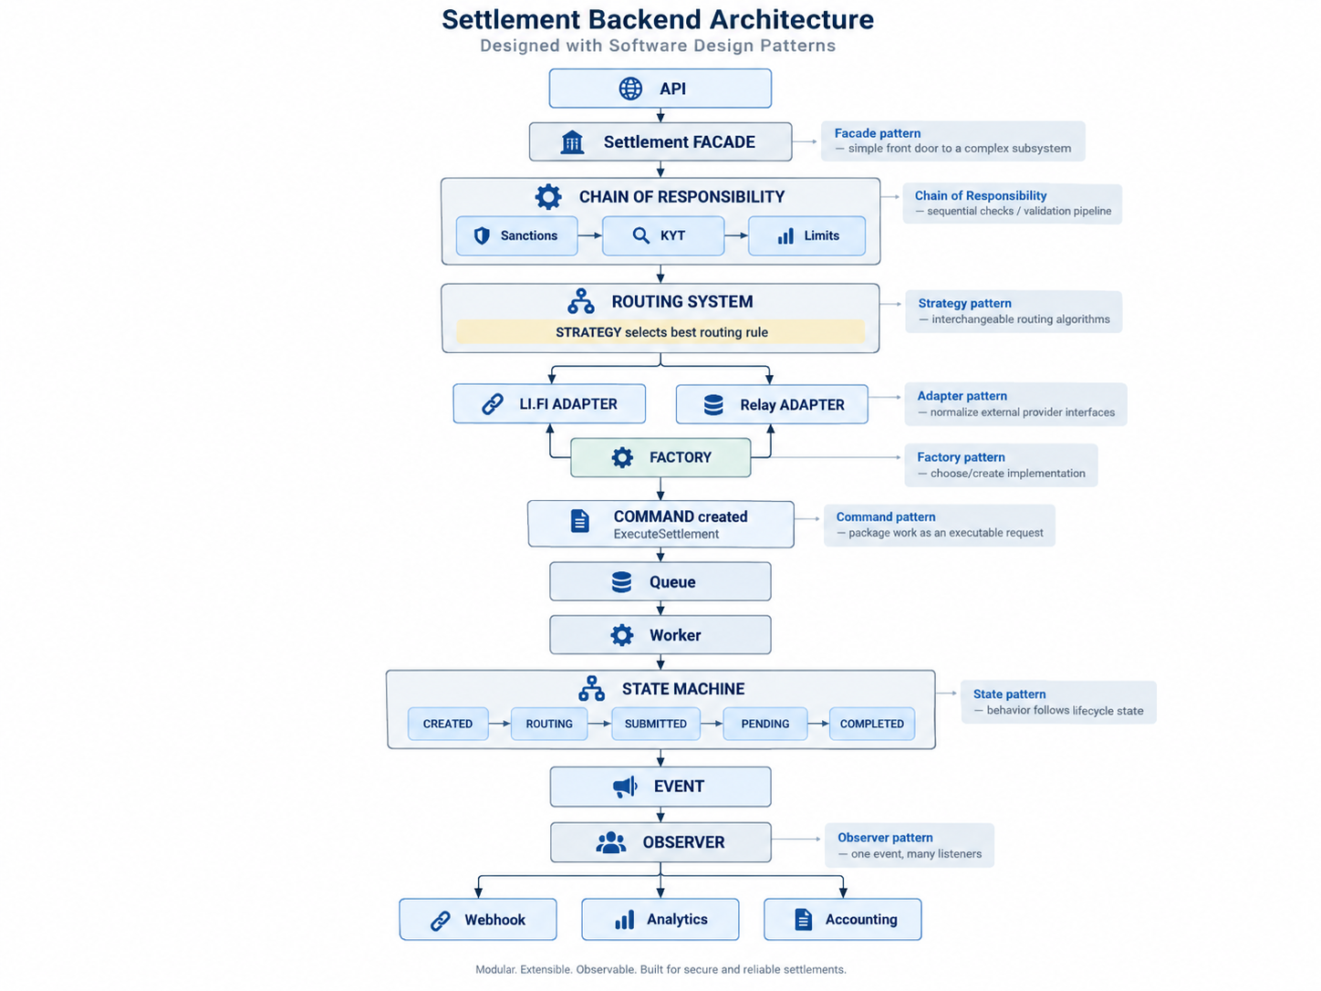
The following conceptual Stridge-like settlement flow demonstrates how several patterns can coexist without being forced into every part of the system.
Around these components, Decorators can add logging, metrics, and tracing; Proxies can provide rate limiting, caching, or authorization; and a Facade can hide subsystem complexity from external callers.

16. Five Patterns to Prioritize

1. Adapter
A strong explanation: "We use a common internal interface around different external providers. For example, LI.FI and Relay can each have adapters implementing the same RouteProvider interface."

2. Strategy
A strong explanation: "If routing can optimize for cost, speed, or risk, each selection algorithm can implement a common Strategy interface and be changed without rewriting the router."

3. Factory
A strong explanation: "Factories centralize construction of the proper chain/provider implementation, for example choosing an EVM, Bitcoin, or Solana client based on network configuration."

4. State
A strong explanation: "A settlement lifecycle is naturally modeled as a state machine so only legal transitions such as CREATED -> ROUTING -> SUBMITTED -> COMPLETED are allowed."

5. Chain of Responsibility
A strong explanation: "Compliance or transaction validation can be a chain of independent checks - sanctions, KYT, limits, balance - where any check may reject the transaction."

